RESOLUTION NO.__________

RE: CERTIFICATE OF APPROPRIATENESS UNDER THE
PROVISIONS OF THE ACT OF THE PENNSYLVANIA
LEGISLATURE 1961, JUNE 13, P.L. 282 (53
SECTION 8004) AND BETHLEHEM ORDINANCE NO.
3952 AS AMENDED.

WHEREAS, it is proposed to install signage, install an awning, and replace the front door at 335 S. New St.

NOW, THEREFORE, BE IT RESOLVED by the Council of the City of Bethlehem that a Certificate of Appropriateness is hereby granted for the work.

Sponsored by: (s)

(s)

ADOPTED BY COUNCIL THIS DAY OF

(s)
President of Council

ATTEST:

(s)
City Clerk

HISTORIC CONSERVATION COMMISSION

CASE # 421 – It is proposed to install signage, install an awning, and replace the front door at 335 S. New St. OWNER/APPLICANT: Wind Drift Real Estate Assoc./ Blue Sky Annex LLC

The Commission upon motion by Mr. Cornish and seconded by Mr. Roeder adopted the proposal that City Council issue a Certificate of Appropriateness for the proposed work described herein:

- The proposal to install signage, install an awning, and replace the front door at 335 S. New St. was presented by Kendis Ashley Caldwell and Beth Elliott.

- “335” will be painted above the door and “Blue Sky Annex” above the window in “Poppy Seed” color (Behr UL260-23).

- A new awning fabricated of black Sunbrella fabric will be installed over the small storefront. The awning will be 87” wide, 30” deep, and 18” high with a 10” high valance. The awning will have no ends (wings), and it will be hung under the cornice projection. The awning will be 10’-6” at the high point and 7’-6” at the lowest point of the valance. “Full of Crepe – Sweet Love Cupcakes” will be installed on the valance in sea blue lettering.

- A blade sign may be installed on a traditional black metal bracket above the storefront cornice, centered between the windows. The maximum size will be 24” x 30”. The final design must be approved by the Historic Officer, and the bracket should be mounted to the façade with fasteners located in mortar joints rather than the brick faces. Any lighting of the sign must return to the Commission for approval.

- The existing non-historic front door (and jamb) will be replaced with a dark bronze aluminum full glass door with a 10” bottom rail.

- New signage may also be installed on the upper sash of the front window. A light color must be used for the new sign, and it will read “Full of Crepe – Sweet Love Cupcakes”. The size of the sign must conform to zoning regulations. The font will match the other signs, and the sign must be approved by the Historic Officer.

- The proposed motion was unanimously approved.

CU: cu

By: 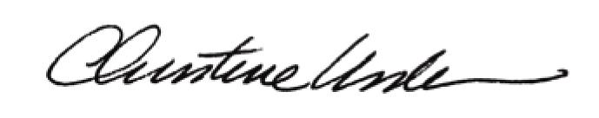

Date of Meeting: July 16, 2012 Title: Historic Officer

